**Table of content**

I. Install Ruby, devkit and utilities 2

1. Install Ruby (Version: 2.1.5) 2

2. Update rubygems (Version 2.4.8) 3

3. Install devkit (Version 4.7.2) 3

4. Install Mysql2 (Version 0.3.20) 5

5. Install QT (pre-require for capybara-webkit) 5

6. Install “gruff” chart gem 11

7. Install Java JDK 13

II. Get Rails Application source code 13

III. Install MySQL and Front end applications 13

1. Install mysql-installer-community-5.7.9.0.msi on server machine 14

2. Install MySQL Front end applications 15

3. Add Workbench tool to PATH system variable 15

IV. Add needed RAILS system variables 15

V. Create database 16

VI. Configure email server 16

VII. Configure browsers for running script 17

VIII. Start Rails Application 25

**Deploy and Configure Rails Application on a machine**

# Install Ruby, devkit and utilities

You can download rubyinstaller and devkit on [RubyInstaller](http://rubyinstaller.org/downloads/) site

## *Install Ruby (Version: 2.1.5)*

Install **rubyinstaller-2.1.5.exe** file and follow steps to set up:

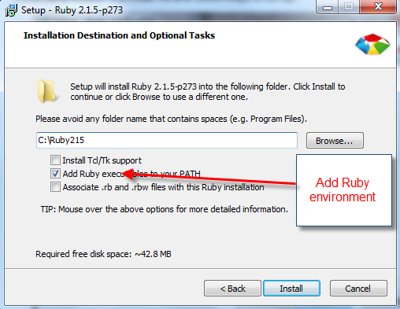

*Note:*

* *After Ruby was installed successfully, make sure that CMD can recognize ruby statement by typing ‘ruby -v ‘or ‘gem list’.*

*If not, you need to add Ruby environment path:*

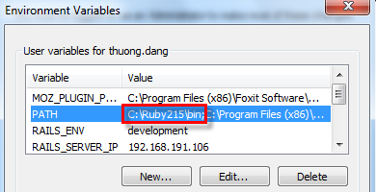

## *Update rubygems (Version 2.4.8)*

* Open cmd
* Type **‘gem update --system 2.4.8’**

*If you get an error when installing, likes this:*

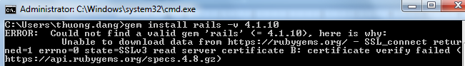

*Please copy* ***cacert.pem*** *from* ***sqaauto_testcentral******/lib/assets*** *into {C:\Ruby215}\lib\ruby\2.1.0\rubygems\ssl_certs folder path.*

## *Install devkit (Version 4.7.2)*

*Please make sure that the DevKit’s v*ersion corresponds to Ruby’s version (32bits or 64bits)

* + - *Copy ‘D*evKit-mingw64-32-4.7.2-20130224-1151-sfx.exe’file from server
    - Extract this file to **C:\DevKit** folder. If you open **C:\DevKit** folder, it looks like:

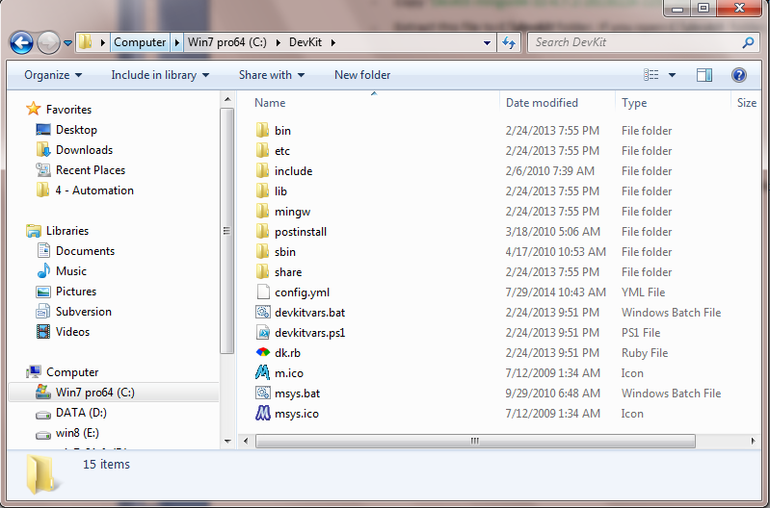

* Open CMD
* Cd to **C:\DevKit**
* Type ***ruby dk.rb init***
* Type ***ruby dk.rb install***
* Add ***C:*DevKit*\bin*** to system path environment like this:

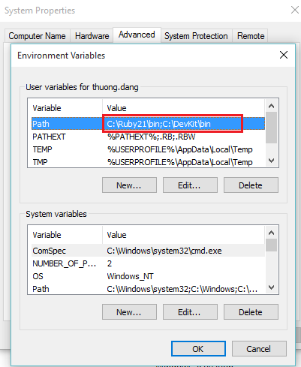

## *Install Mysql2 (Version 0.3.20)*

* Download Connector/C 6.1.6 ARCHIVE Connector (mysql-connector-c-6.1.6-win32.zip) from: <http://dev.mysql.com/downloads/connector/c/>
* Extract the file to C:\mysql-connector-c-6.1.6-win32
* Run command in the command line: *gem install mysql2 -v 0.3.20 -- '--with-mysql-lib="C:\mysql-connector-c-6.1.6-win32\lib" --with-mysql-include="C:\mysql-connector-c-6.1.6-win32\include"'*

## *Install QT (pre-require for capybara-webkit)*

*Capybara-webkit aims to run test scripts with webkit driver instead of selenium web driver*

**Software’s version:**

* ~~rubyinstaller-2.1.5.exe~~
* ~~DevKit-mingw64-32-4.7.2-20130224-1151-sfx.exe~~
* qt-opensource-windows-x86-mingw482-4.8.6-1.exe

**Steps:**

1. install ruby (refer to I.1)
2. install devkit (refer to I.3)
3. install QT
4. 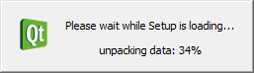
5. 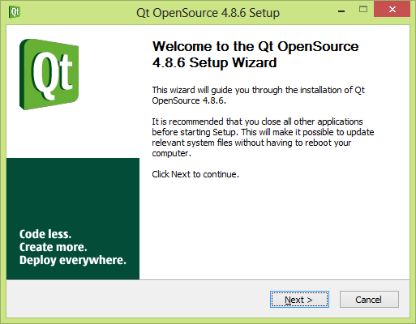
6. 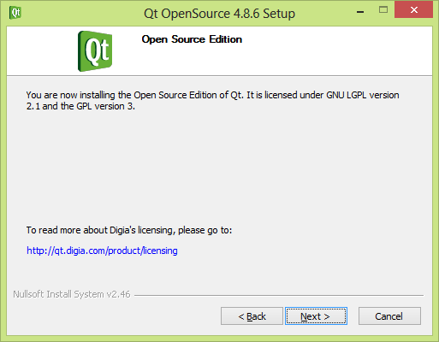
7. 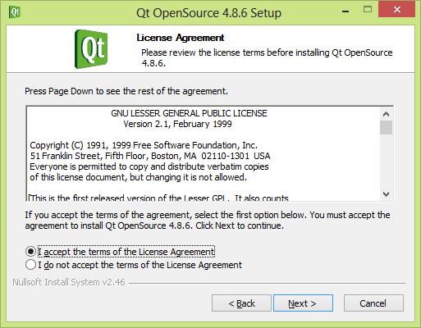
8. 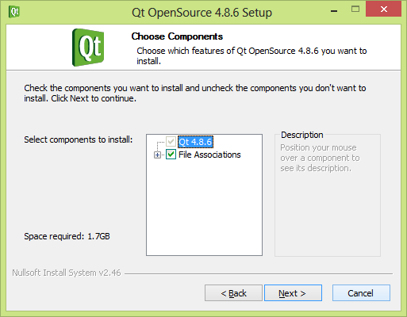
9. 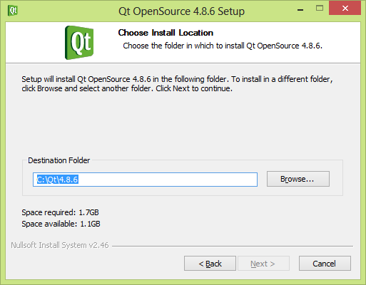
10. 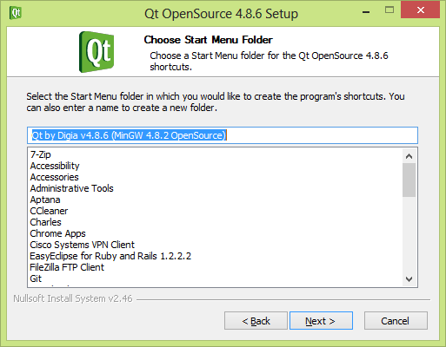

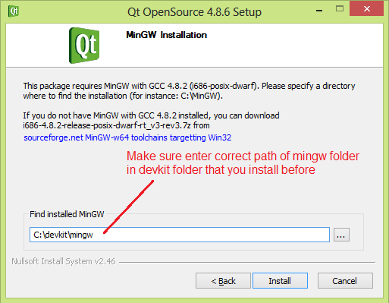

1. Install and add “C:\Qt\4.8.6\bin” to system path environment like this:

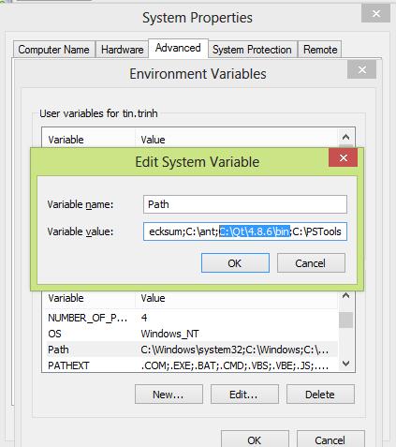

1. Edit content of “qmake.conf” file (C:\Qt\4.8.6\mkspecs\win32-g++):

Add “QMAKE_LFLAGS = -static-libgcc -static-libstdc++” line:

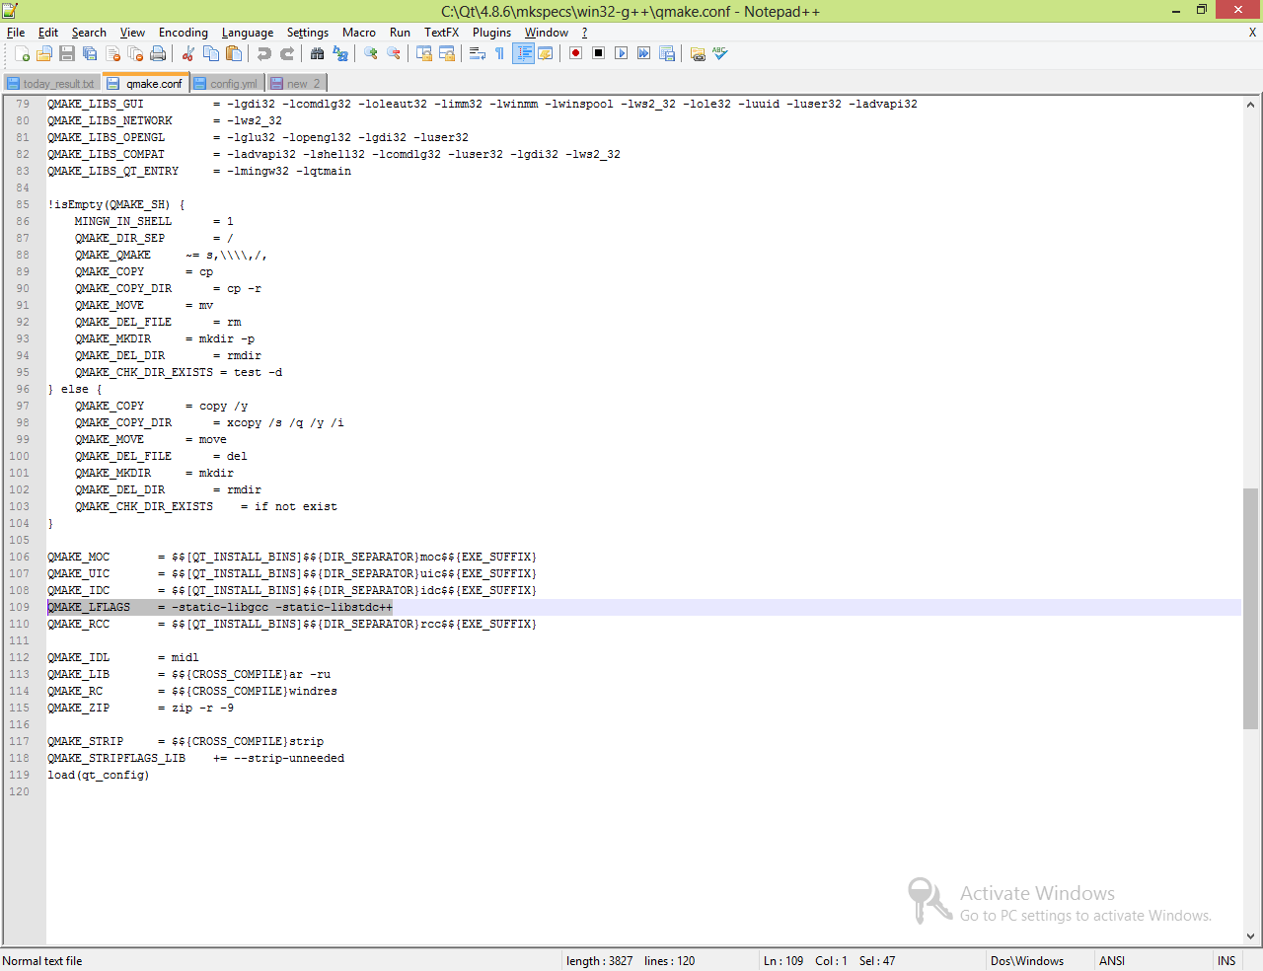

1. Make sure these variable values “C:\Ruby215\bin;C:\devkit\bin;C:\Qt\4.8.6\bin;” are added into system path environment

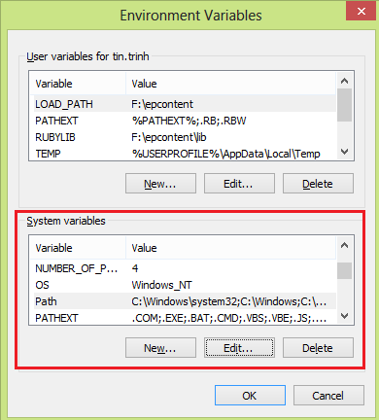

## *Install “gruff” chart gem*

1. Install ‘ImageMagick’ dll
   * + Software‘s link: <http://www.imagemagick.org/download/binaries/ImageMagick-6.9.2-4-Q16-x86-dll.exe> or newer
     + Make sure “Select Additional Tasks” step like below image:

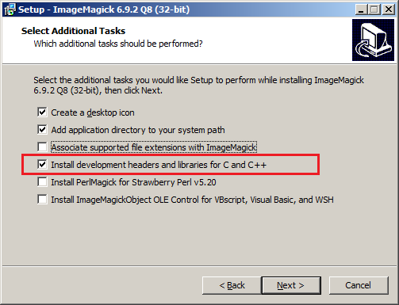

* + - Make sure ‘C:\Program Files (x86)\ImageMagick-6.9.2-Q8’ exist in System Path

1. Install ‘gruff’ gem version 0.6.0
   * + In command line: **gem install gruff –v 0.6.****0**

## *Install Java JDK*

1. Download and install Java JDK 64/32 bits version **>=1.8,** e.g. jdk1.8.0_60
   * + Software’s link: [http://www.oracle.com/technetwork/java/javase/downloads/index.html](http://www.oracle.com/technetwork/java/javase/downloads/index.html%20)
2. Make sure that **JAVA_HOME** is added to system variables with value **C:\Program Files\Java\jdk1.8.0_60**

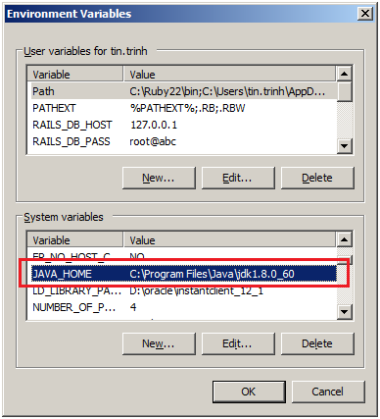

# Get Rails Application source code

Make sure that you installed Git and added SSL Key into stash

* + - Link to get source code:

<ssh://git@stash.leapfrog.com:7999/sqaa/sqaauto_testcentral.git>

# Install MySQL and Front end applications

* + MySql Labs 5.7.8-rc or newer w/ JSON (**recommended**): Please refer to MySQL.md document
  + MySQL 5.7.9.0 or newer for Windows: use it only for development

## *Install mysql-installer-community-5.7.9.0.msi on server machine*

Please follow the MySQL installation steps

## *Install MySQL Front end applications*

* + - [*MySQL Workbench*](https://www.mysql.com/products/workbench/)*: mysql-workbench-community-6.3.4-win32.msi or newer (recommended)*
    - [*MySQL-Front*](http://www.mysqlfront.de/)*: newest*

## *Add Workbench tool to PATH system variable*

C:\Program Files\MySQL\MySQL Workbench 6.3 CE;

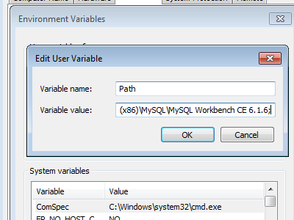

# Add needed RAILS system variables

Add the following system variables:

RAILS_DB_USER=[database user, e.g. root]

RAILS_DB_PASS=[database pass]

RAILS_DB_HOST=[database ip, e.g. 127.0.0.1]

RAILS_DB_PORT=[database port, e.g. 3306]

RAILS_ENV=production

RAILS_SERVER_IP=[ip of rails server, e.g. 190.168.190.122]

RAILS_SERVER_PORT=443

RAILS_TIME_ZONE=[time zone, e.g. Hanoi]

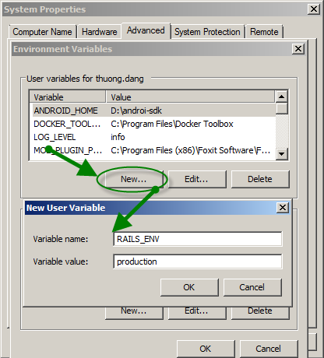

# Configure email server

You need to set up email server environment (dev or prod) before running script. To do that, open the **‘sqaauto_testcentral/config/machine.xml’**and change the smtp settings accordingly.

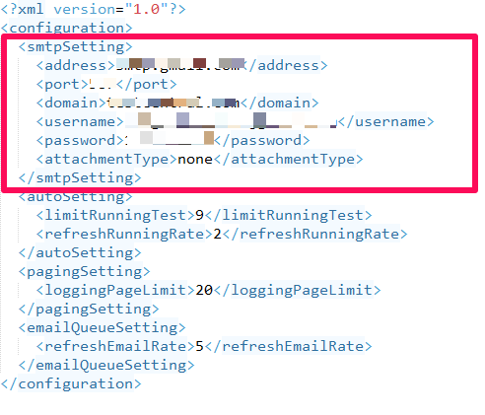

# Configure browsers for running script

* **INTERNET EXPLORER**

1. Require: IE 11 installed
2. Go to IE/Internet Option/Security Tab
3. Enable “Protected Mode” for all “Internet”, “Local Intranet”, “Trusted Site”, “Restricted sites”

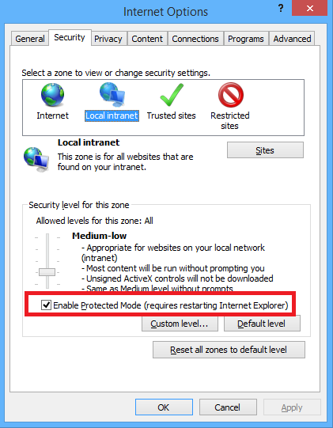

1. Go to Advance Tab
2. Disable “Enhanced Protected Mode” if it is enabled

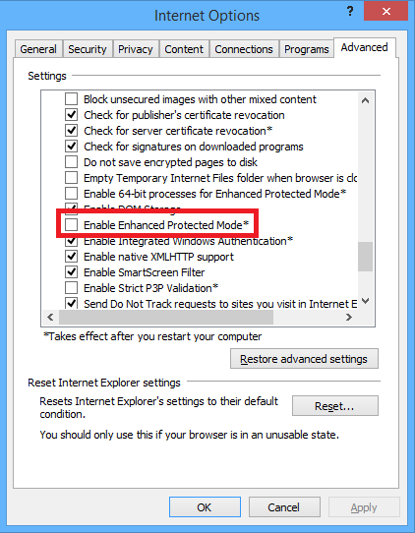

1. Set Zoom Level of IE to 100%

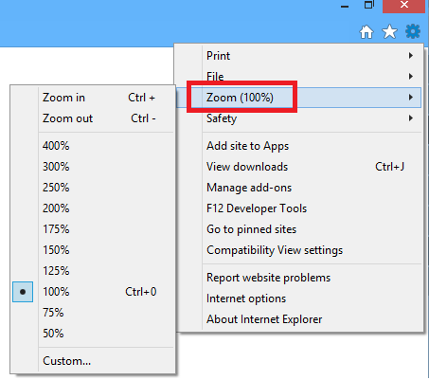

1. [Automatically clear private data when closing your browser](http://www.howtogeek.com/137681/how-to-automatically-clear-private-data-when-you-close-your-browser/)
   * Internet Explorer has the built-in ability to clear its private data when you close it, too. Click the gear icon and select Internet options to get started

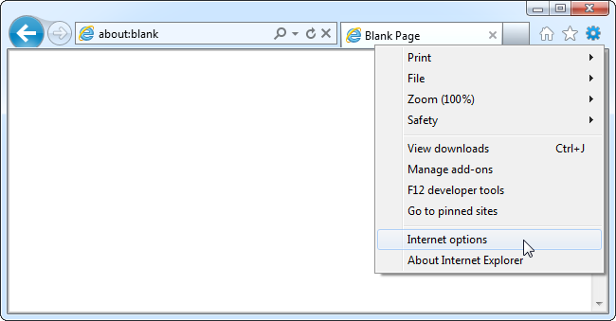

* + On the General tab, enable the “Delete browsing history on exit” option
  + Click the Delete button to customize which types of data Internet Explorer will clear. You may want to uncheck “Preserve Favorites website data” or Internet Explorer will keep cookies and cache files for websites you have saved as favorites.
  + Click the Delete button when you are done. Internet Explorer will immediately clear your private data and then clear it each time you close your browser.
* **FIREFOX**

1. Require: Firefox version 46
2. [Automatically clear private data when closing your browser](http://www.howtogeek.com/137681/how-to-automatically-clear-private-data-when-you-close-your-browser/)
   * Firefox has the built-in ability to clear all your private data when you close it – no extensions required. To get started, open the Firefox menu and select Options

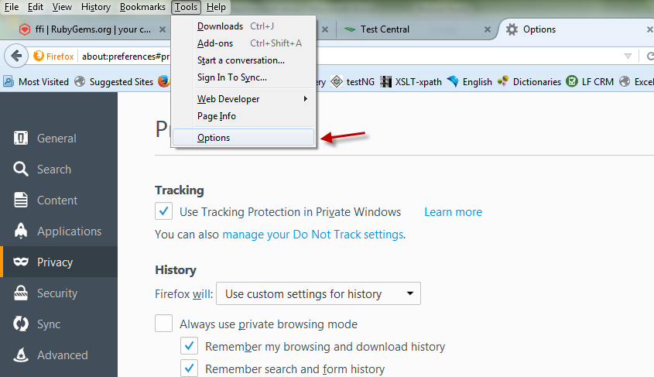

* + Select the Privacy icon and choose “Use custom settings for history.” Enable the “Clear history when Firefox closes” check box

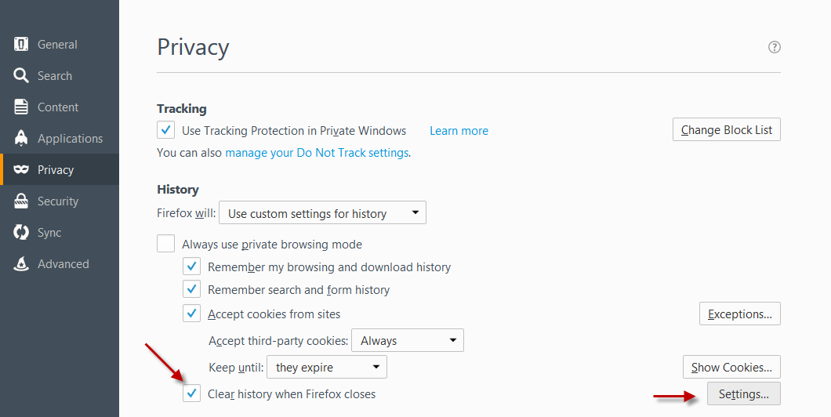

* + To control which types of private data Firefox automatically clears, click the Settings button and choose the types of private date you don’t want

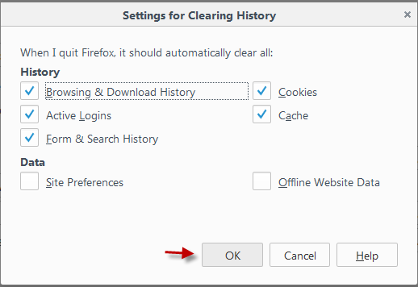

* **CHROME**

1. Require: Chrome latest version
2. [Automatically clear private data when closing your browser](http://www.howtogeek.com/137681/how-to-automatically-clear-private-data-when-you-close-your-browser/)
   * Open the Settings screen from Chrome’s menu

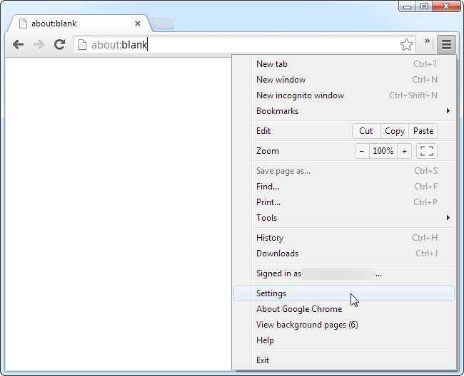

* + Click the Show advanced settings link at the bottom of the Settings page

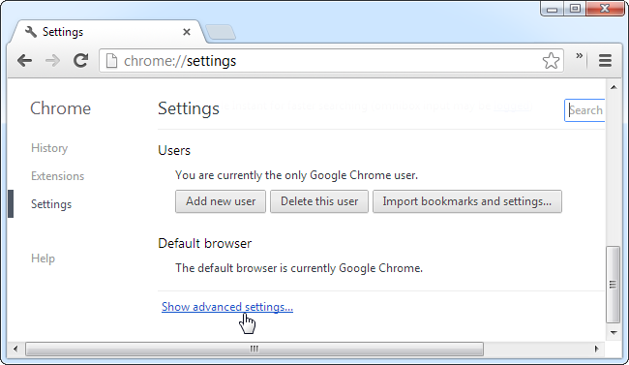

* + Click the Content settings button under the Privacy header

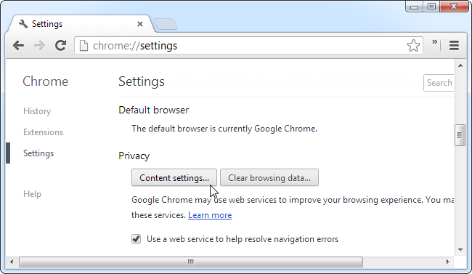

* + Under Cookies, select “Keep local data only until I quit my browser” and click OK. When you close Chrome, it will now automatically clear your cookies

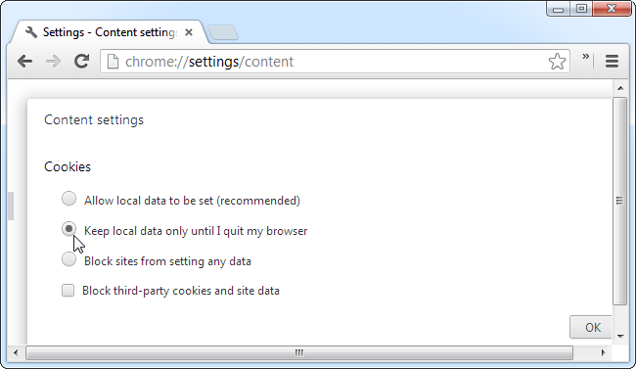

# Start Rails Application

* + - Open CMD and cd to **/sqaauto_testcentral**
* Type **bundle install**
  + - *This command will install all missing gems: json, rake, tzinfo…*
    - *If you get errors related to install json, rake... Please ensure that version on Ruby and DevKit are the same architecture (32 or 64 bit).*

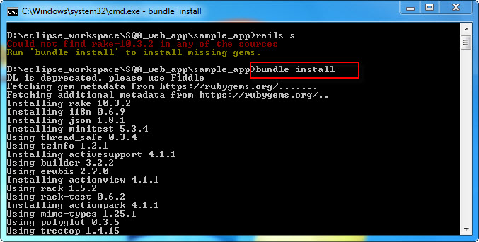

* Create database
  + - Run **rake db:setup SKIP_SCHEDULERS=1**
    - **Deploy Test Central with nginx and puma**

1. Download [latest Nginx Stable version](http://nginx.org/en/download.html) for Windows

Extract nginx*.zip and edit conf/nginx.conf as below:

worker_processes 1;

error_log logs/error.log;

error_log logs/error.log notice;

error_log logs/error.log info;

pid logs/nginx.pid;

events {

worker_connections 1024;

}

http {

upstream puma {

server 127.0.0.1:9292;

}

include mime.types;

default_type application/octet-stream;

sendfile on;

keepalive_timeout 65;

server {

listen 443 ssl;

listen [::]:443 ssl;

ssl on;

ssl_certificate path\to\ssl\server.crt; # Change this path to your correct sqaauto_testcentral folder

ssl_certificate_key path\to\ssl\server.key; # Change this to your correct sqaauto_testcentral folder

root path\to\public; # Change this path to your correct sqaauto_testcentral folder

server_name testcentral;

client_max_body_size 110M;

underscores_in_headers on;

location / {

proxy_pass http://puma; # match the name of upstream directive which is defined in line 1

proxy_set_header Host $host;

proxy_set_header X-Forwarded-Proto $scheme;

proxy_set_header X-Forwarded-For $proxy_add_x_forwarded_for;

proxy_set_header X-Real-IP $remote_addr;

proxy_read_timeout 600;

}

}

}

1. Start puma

Open CMD and cd to sqaauto_testcentral folder, enter: **puma**

1. Start nginx

Open CMD and cd to nginx extracted folder, enter: **start nginx.exe**

* + - Run Rails Application on browser

Navigate to**:** [**https://localhost/**](https://localhost/)or**https://{machine_ip_address}/**

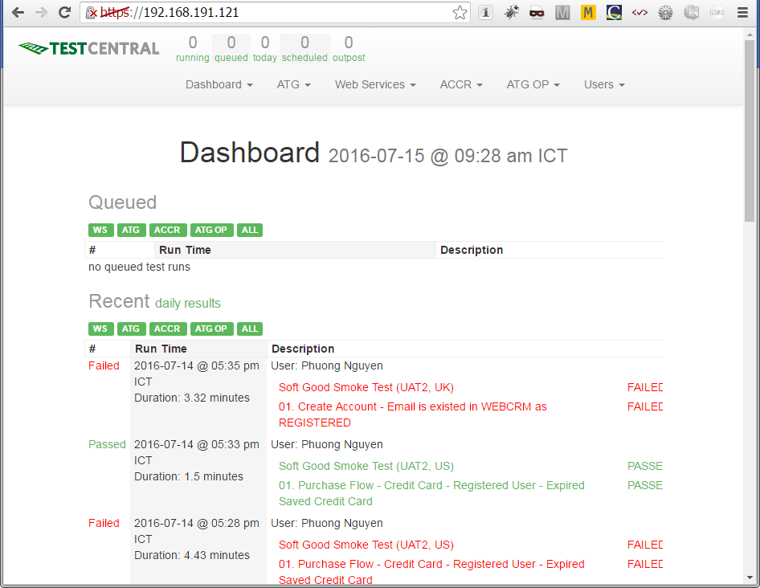

**Reference**

[nginx for Windows](http://nginx.org/en/docs/windows.html)

Nginx on Windows runs as a standard console application (not a service), and it can be managed using the following commands:

**nginx -s stop:** fast shutdown

**nginx -s quit:** graceful shutdown

**nginx -s reload:** changing configuration, starting new worker processes with a new configuration, graceful shutdown of old worker processes

**nginx -s reopen:** re-opening log files